Download Docker, Java (17 to 21), Jenkins LTS
C:\jenkins\
└── jenkins.war

cd C:\jenkins
java -jar jenkins.war

Installation will happen

After installed
In the command prompt it will show the admin password created copy and store it to login into admin account in Jenkins page.

http://localhost:8080 in browser
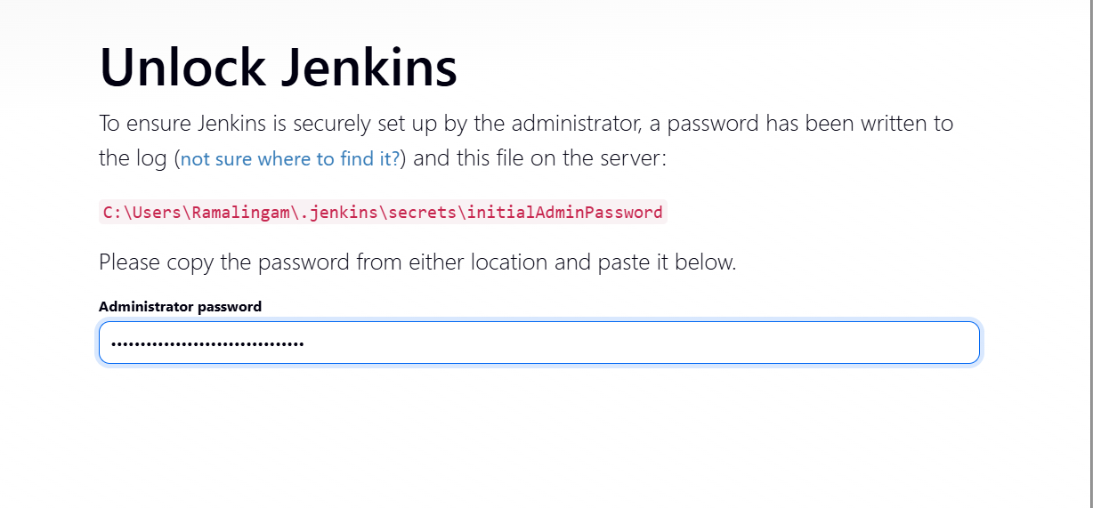

Click install and suggested packages
It will download and install all required APIs. Make sure the internet is connected

Once everything is over. It will ask to create a admin account and use the already created admin password.
Once everything over. Jenkins is ready for use
Donot close the command prompt window to continue using Jenkins. If close do this again in command prompt.

C:\jenkins\
└── jenkins.war

cd C:\jenkins
java -jar jenkins.war

🔹 STEP 1: Create First Job

Click New Item (left side)

Enter job name:

First-Jenkins-Job

Select:
✅ Freestyle project

Click OK

🔹 STEP 2: Configure the Job

Scroll to Build Steps

Click Add build step

Select:

Execute shell → Linux / macOS
Execute Windows batch command → Windows

Paste this:

echo Jenkins is working successfully
date /t
time /t

Click Save

🔹 STEP 3: Run the Job

Click Build Now

A build number (#1) appears

Click it → Console Output

✅ Expected Output:
Jenkins is working successfully
Fri Dec 26 ...

🎉 This confirms Jenkins can execute jobs.

Develop a python file and push to github account
Create a new job in Jenkins
Go to configure Source Code Management -> Choose GIT and Give the GIT repository URL
Then Branches to build - > change according to branch name */main or */master
Goto Triggers ->Check Poll SCM -> Use cron expression * * * * * or H/1 * * * * *

Then Goto Build Steps -> command to execute the file (python new.py)
Choose Execute Windows batch command based on windows or Linux or mac

Click Appy and Save

H/1 * * * * * -> Tracks the git file every 1 min

Click Buildnow
See console output to see the results

After successful output in console. Make changes in the source file in VS Code and push to GITHUB. Check for the next build in Jenkins. Automatically that change will be captured by Jenkins

